Technical Specifications

International Public Tender

Interactive Displays 2026

**Table of contents**

1. Call Aim 3

2. Requirements 4

2.1. Interactive Displays 4

2.2. Floor stand for classroom installation 5

2.3. Management System 6

3. Warranty 7

3.1. Systemic Failures 7

4. Delivery deadlines 7

5. Offer 8

5.1. Documentation 9

5.2. Samples 9

5.3. Demos management system 10

6. Evaluation Criteria 11

6.1. Background 11

6.2. Compliance with the mandatory requirements 11

6.3. Interactive Display 11

6.4. Management System 11

7. Annex I: Price Tables 12

8. Annex II: Confidentiality and data protection 13

# 

# 

# 

# Call Aim

Centro Ceibal calls for International Public Tender for the acquisition of interactive displays to use in classrooms, and associated services.

The following products and services are of MANDATORY quotation in this offer:

1. 65” interactive displays.
2. Floor stand for display installation.
3. Remote management system for displays for a minimum period of 10 years.
4. 3-year warranty.

**Each bidder may offer a maximum of 2 interactive display models with their corresponding stands.**

Additionally, the bidder must provide technical support in case of failures due to misuse. To this end, they must indicate where they have service centers within the national territory.

The solution must comply with the confidentiality and data protection considerations specified in

*Annex II: Confidentiality and Data Protection.*

# Requirements

This section describes the requirements for the products and services being tendered.

It is a mandatory requirement to have Google EDLA certification, either native or via OPS. For the technical evaluation, **samples and/or DEMO of the offered models that do not have this certification at the time of submission will be accepted. The bidder must prove the certification has been obtained prior to the first shipment.**

## Interactive Displays

| **MANDATORY REQUIREMENTS** | | | | |
| --- | --- | --- | --- | --- |
| **MANDATORY REQUIREMENTS** | | **COMPLIES** | | **SPECIFICATIONS AND OBSERVATIONS** |
| YES | NO |
| 2.1.1 | Size 65'' |  |  |  |
| 2.1.2 | Google EDLA Certification |  |  |  |
| 2.1.3 | LCD o LED type screen |  |  |  |
| 2.1.4 | Minimum Resolution: 3840x2160px |  |  |  |
| 2.1.5 | Touch screen: At least 20 points of touch, |  |  |  |
| 2.1.6 | Operating System: Android 13 or higher. |  |  |  |
| 2.1.7 | Operating system and all its interfaces and configuration options in Spanish language from factory. |  |  |  |
| 2.1.8 | Minimum storage: 128GB |  |  |  |
| 2.1.9 | Minimum RAM memory: 8GB |  |  |  |
| 2.1.10 | 220VAC plug: Schuko CEE 7/4, CEE 7/7, or 3 in line (CEI 23-50 S11) |  |  |  |
| 2.1.11 | Power cable: minimum length 3mts, minimum section 3x0.75 mm2, and 100% copper conductors. |  |  |  |
| 2.1.12 | Stereo speakers |  |  |  |
| 2.1.13 | Connectivity:  WiFi Minimum: dual band 1x1: 802.11n (2.4 GHz) and 802.11ac (5GHz).  Personal WPA2 security. If the TV does not have built-in WiFi module, a solution with external WiFi module is acceptable. Specify supported 802.11 and MIMO protocols.  Ethernet |  |  |  |
| 2.1.14 | Minimum number of ports:  2x HDMI  2x USB 3.0  1x Audio Input  1x RJ45 |  |  |  |
| 2.1.15 | VESA mounting standard |  |  |  |
| 2.1.16 | At least one technical service center with a presence in Uruguay. Include the service specifications and location in the offer. |  |  |  |
| **DESIRABLE REQUIREMENTS** | | **COMPLIES** | | **SPECIFICATIONS AND OBSERVATIONS** |
| YES | NO |
| 2.1.17 | Minimum Bluetooth 4.0 connectivity. |  |  |  |
| 2.1.18 | Provide the device's Platform Key for Ceibal application development or, failing that, the ability to sign applications. |  |  |  |

## Floor stand for classroom installation

| **MANDATORY REQUIREMENTS** | | | | |
| --- | --- | --- | --- | --- |
| **MANDATORY REQUIREMENTS** | | **COMPLIES** | | **SPECIFICATIONS AND OBSERVATIONS** |
| YES | NO |
| 2.2.1 | VESA standard mounting |  |  |  |
| 2.2.2 | 4 lateral support points |  |  |  |
| 2.2.3 | Braking system for wheels |  |  |  |
| 2.2.4 | Floor support design according to image 1. **Platform/center foot supports are not accepted.** |  |  |  |
| 2.2.5 | Maximum weight supported: over 80kg |  |  |  |

**Image 1:** lower floor support design (mandatory requirement 2.2.4).

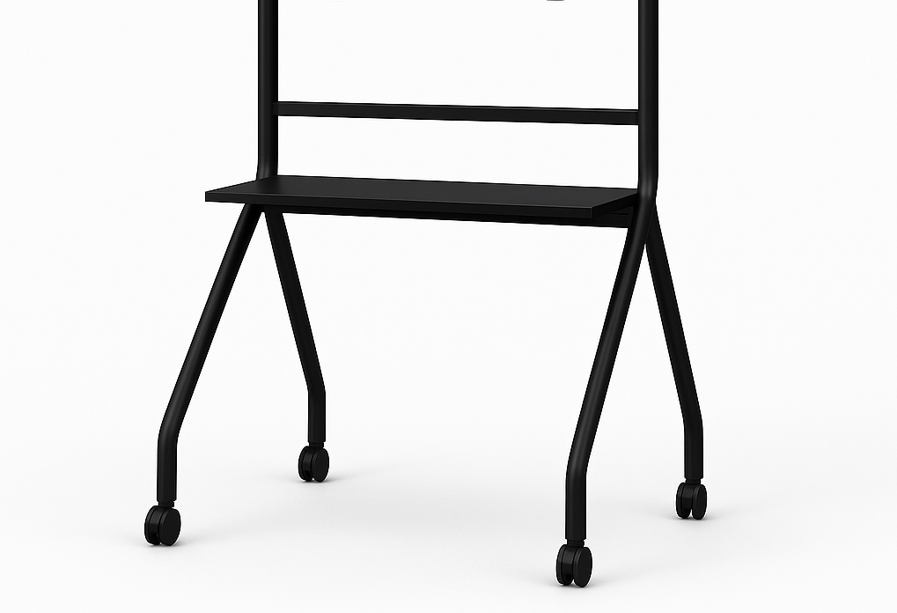

## Management system

The offer must include a remote display management system in SaaS mode. Through this management system, Ceibal will configure the interactive displays, send updates and applications, segment the display universe according to specific criteria, and perform basic troubleshooting.

The management system is an integral part of the solution, cannot be quoted separately, and must support the deployed solution for a minimum of 10 years.

**During the evaluation of offers, Ceibal may request a DEMO of the proposed management system from the bidder.**

# Warranty

The bidder guarantees that the products supplied under the contract are new, complete, unused, and free from defects attributable to design, materials, manufacturing, storage conditions (appropriate packaging, temperature, and humidity), transportation, or any act or omission by the bidder that may arise during normal use of the products under the prevailing conditions in the country.

## Systemic Failures

Ceibal may request the successful bidder to provide necessary spare parts or replace equipment in case a systemic failure attributable to the design or manufacturing of the equipment is detected. The costs derived from the execution of this warranty are the exclusive responsibility of the supplier. This includes systemic software failures not attributable to Ceibal.

The displays must have a minimum warranty of **3 years**. Specify the warranty period for the stand.

# Delivery Times

The following maximum delivery times are desirable:

* Initial delivery of one container of interactive displays and their respective floor stands (approximately 200 displays) with ETA Montevideo 120 calendar days after the award resolution is communicated.
* ETA Montevideo for the rest of the awarded batch:
  + 50%: within 30 calendar days after the initial delivery.
  + 50%: within 60 calendar days after the initial delivery.

If these deadlines cannot be met, the bidder must specify the proposed delivery times in their offer.

# Offer

**Each bidder may offer a maximum of 2 models.** All submitted documentation must be segmented, **identifying each product by its corresponding model in the technical and economic offers.**

The technical offer must be presented according to the following segmentation, **and all tables provided by Ceibal must be submitted in PDF and editable formats:**

1. Folder with background specifications. It must detail:

Background information on the provision of interactive screens. **Particularly**

**those associated with educational projects should be indicated.**

List of clients and respective contacts.

1. Folder with the following completed tables from Section 2. *Requirements*:

Section 2.1 *Interactive Display.*

Section 2.2 *Floor Stand for Classroom Installation.*

1. Folder with specifications of the proposed management system.
2. Folder with specifications of technical support services in the country, including the location of the center(s).
3. Folder with the documentation requested in Section 5.2 Complete documentation for each offered interactive display and floor stand model.
4. Folder with delivery time specifications. If the desirable delivery times specified in Section 4. *Delivery Times* cannot be met, indicate the proposed delivery times.
5. Folder with specifications of privacy and data security policies, as specified in Annex II: Confidentiality and Data Protection.
6. (Optional) Folder with any additional technical information the bidder deems relevant to provide.

The economic offer must include a folder with the completed tables from Annex I: Price Tables for the corresponding display.

**For the methodology of offer submission, refer to the General Specifications.**

##### 

## Documentation

The offer must include the following documentation:

| **DOCUMENTATION** | |
| --- | --- |
| MANDATORY WITH THE OFFER | |
| 5.2.1 | Technical specifications of the interactive display |
| 5.2.2 | Technical specifications of the WiFi card |
| 5.2.3 | Technical specifications of the floor stand |
| 5.2.5 | Indicate whether there is the possibility of consuming APIs for data retrieval and display management |
| MANDATORY PRIOR TO DELIVERY OF THE AWARDED PRODUCT | |
| 5.2.6 | Interactive display user manual in Spanish |
| 5.2.7 | Management system user manual in Spanish |
| 5.2.8 | EDLA Certification . |

Manuals 5.2.6 and 5.2.7 may be submitted at the time of the offer.

## Samples

The bidder may deliver **ONE** sample of each offered model at the time of offer opening. If Ceibal already has a sample of the offered equipment, the bidder must explicitly declare this in their offer, indicating that said display is representative of the offered model.

**In exceptional cases and when justified at Ceibal’s discretion, the bidder may defer the delivery of samples for a reasonable period, which Ceibal will evaluate.**

If the sample delivery deadlines cannot be met, the bidder must arrange for two evaluators designated by Ceibal to assess the sample at a location where it can be evaluated, within the territory of Uruguay, at the bidder’s sole expense.

It is **mandatory** to deliver **ONE** sample of the offered floor stand at the time of offer opening.

Samples must be delivered to Ceibal Purchase Department (Av Italia 6201, Predio LATU, edificio Los Ceibos, CP 11500). Public service hours are Monday to Friday from 9:30 AM to 4:00 PM.

A fundamental part of the technical evaluation will be conducted on these samples. The specifications and performance of the final product must not be inferior to those of the sample. This aspect will be verified in the quality controls that determine product acceptance.

Bidders who are not awarded will have 4 weeks from the award date to retrieve the submitted samples. If the samples are not retrieved within this period, Ceibal Center may freely dispose of them without any claim from the bidder. Samples delivered by awarded bidders will remain the property of Ceibal.

## Management System Demo

Ceibal may request a DEMO of the management system, either in person or remotely, on a date and methodology to be agreed upon with the bidder.

The table below indicates, for reference, the functionalities sought in the system.

| **MANAGEMENT SYSTEM FUNCTIONALITIES** | |
| --- | --- |
| 5.3.1 | All interfaces in Spanish. |
| 5.3.2 | Remote and transparent sending, installation/uninstallation, and updating of applications (APKs) to individual displays or specific groups of displays. |
| 5.3.3 | HTTPS and management and administration of SSL certificates. |
| 5.3.4 | Display the on/off status of the equipment, as well as the on/off history for a given period (e.g., 1 month). |
| 5.3.5 | Segmentation of displays for monitoring based on different criteria, e.g., specific displays, sets of displays by serial number, etc. |
| 5.3.6 | Display application usage and runtime. |
| 5.3.7 | Observe and take remote control of the display. |
| 5.3.8 | Monitor hardware status (CPU, RAM, storage, etc.). |
| 5.3.9 | Remote restart and shutdown. |
| 5.3.10 | Sending push notifications (plain text, multimedia, hyperlinks, etc.). |
| 5.3.11 | Sending multimedia files. |
| 5.3.12 | Remote factory reset or restoration to a known previous state. |
| 5.3.13 | Remote wallpaper configuration. |
| 5.3.14 | Operating system upgrades and remote Android updates. |
| 5.3.15 | User role configuration and access password management. |
| 5.3.16 | Log of system actions. |
| 5.3.17 | Possibility of consuming APIs for data retrieval and display management. |
| 5.3.18 | USB port locking and disabling debug mode. |

# Evaluation Criteria

This section details the criteria for evaluating the offers.

## Background

The bidder’s background in providing interactive displays, educational project-related background, and experience working with Ceibal will be evaluated.

## Compliance with Mandatory Requirements

Any offer that does not meet any of the mandatory requirements specified in the corresponding category of Section 2. *Requirements* will be disqualified.

## Interactive Display

The evaluation of the interactive display will be conducted with a product sample, as specified in Section 5. Offer. Similarly, the offered floor stand will be evaluated with the submitted sample. For reference, the aspects covered in the display evaluation are listed below:

* Educational Usability: Position of physical buttons and speakers, use of the whiteboard application, screen sharing, and YouTube, among others.
* Software Features: Installation and execution of Ceibal applications, connection of peripherals physically and wirelessly, web browser.
* Information Security: Access passwords, application restrictions, factory reset, user roles, USB locking.
* Performance: Performance tests with the PCMark application, display characteristics, review of features with the Dev Check application, connectivity characteristics.

## Management System

Ceibal may request a DEMO of the remote display management system. During the DEMO, Ceibal will evaluate the available system functionalities (see Section 5.3).

# Annex I: Price Tables

The bidder must complete the following table to submit the quotation. **The management system and the 3-year warranty must be included in the display price.** Any additional licenses the bidder wishes to quote must be specified separately.

| **PRICE TABLE** | | |
| --- | --- | --- |
| **INTERACTIVE DISPLAYS with MANAGEMENT SYSTEM and 3-YEAR WARRANTY INCLUDED** | | **Unit Price USD CIF MVD** |
| **Model** | **Volume** |
|  | Up to 500 |  |
| Between 501 and 1000 |  |
| Between 1001 and’ 1500 |  |
| Over 1500 |  |
| **FLOOR STAND** | | **Unit Price USD CIF MVD** |
| Up to 500 | |  |
| Between 501 and 1000 | |  |
| Between 1001 and 1500 | |  |
| Over 1500 | |  |

# Annex II: Confidentiality and Data Protection

The company awarded the contract expressly undertakes to maintain the strictest confidentiality regarding all information processed or used during its relationship with Ceibal Center. Confidential Information includes, but is not limited to, the following: all commercial strategies, plans, and procedures, proprietary information, software, tools, processes, images, personal data, methodologies, commercial information, and trade secrets, as well as any other information and material from Ceibal, its students, beneficiaries, teachers, and educational institutions, which may be obtained by the company from any source or developed as a result of this contract.

**If the bidder accesses personal data, they must indicate in their offer where the data is hosted and their privacy and data security policies.** In this case, they are obligated to process personal data in accordance with Law No. 18.331 of August 11, 2008, and Decree No. 414/2009 of August 31, 2009, solely for the provision and within the scope of the contracted service, and may not use it for any other purpose, for their own benefit, whether free or paid, nor transfer, communicate, or share it with third parties without prior authorization from Ceibal Center.

Access to personal data shall in no case be considered as a transfer or permission for its free use by the selected bidders.

They are also obligated to adopt the necessary security measures to ensure the security and confidentiality of personal data and to prevent its alteration, loss, unauthorized consultation, or processing, as well as to detect information deviations.

If personal data is hosted, even temporarily, outside the national territory, the importer must be located in countries considered to have adequate data protection levels according to European standards, in accordance with Directive 95/46/EC of the European Parliament and Council, as amended, related, and complementary.

Upon termination of this contract, they are obligated to return or delete from all their systems and physical and logical files, whether owned or contracted to third parties, the personal data accessed, obtained, or processed under this contract, as well as the associated metadata, if applicable.

Personal data is considered any type of information referring to identified or identifiable natural or legal persons, including, but not limited to, any numerical, alphabetical, graphic, photographic, acoustic, or other type of information referring to them directly or indirectly, as provided in Article 4 of Law No. 18.331 and Articles 1 and 4 of Decree No. 414/009.